# Instructions - Exercise 3.2 – Passing Data to Routes, Part 1

**Layout**

Composer Details

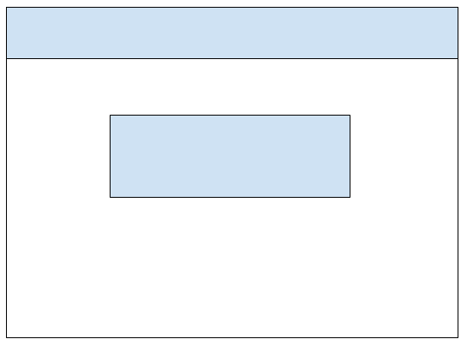

composer-app, part 2

**Instructions**

* Make a copy of the composer app from Assignment 2.4 and add it to your week-3 directory
* Rename the application to enhanced-composer-app
* Delete the node_modules directory
* Delete the package-lock.json file
* Open the angular.json file and find and replace all “composer-app” entries with “enhanced-composer-app”
* Open the package.json file and change the name to “enhanced-composer-app”
* Run npm install and ng serve
  + You are doing this to test the application and confirm there are no errors
* app.component.ts
  + Change the assignment’s name to “Exercise 3.2 - Passing Data to Routes, Part 1
* Generate a new component and name it composer-details
* Create a new TypeScript file under the app directory and name it composer.interface.ts
* Create a new TypeScript file under the app directory and name it composer.class.ts
* Move the Composer class from the composer-list.component.ts to the composer.class.ts file
* composer.interface.ts
  + Rename the interface to IComposer
    - export interface IComposer
  + Add a new field called composerId of type number
  + Add a new field called fullName of type string
  + Add a new field called genre of type string
* composer.class.ts
  + Remove the fullName and genre fields
  + Remove the fullName and genre fields from the constructor’s parameters
  + Remove the code in the body of the constructor
  + Add a new field called composers of type Array<IComposer>
  + In the class’s constructor, populate the composer’s array with 5 composer objects
    - {composerId: 100, fullName: “Wolfgang Amadeus Mozart”, genre: “Classical”}
    - You should be able to reuse most of the code from the body of the constructor in the composer-list.component.ts file.
  + Create two new functions: getComposers() and getComposer(composerId: number)
  + getComposers()
    - Return the composers array
  + getComposer(composerId: number)
    - Loop over the composer array and return the object that matches the passed-in composerId
      * for (let composer of this.composers)
      * Note: do not use any built-in filter functions for this exercise.  I want you to get comfortable with looping over arrays and extracting objects
* composer-list.component.ts
  + Add an import for the IComposer interface
    - import { IComposer } from ‘../composer.interface’
  + Add an import for the Composer class
    - import { Composer } from ‘../composer.class’;
  + Update the composer’s variable to be of type Array<IComposer>
  + In the components constructor create a new Composer object and assign the getComposers() function to the composers variable
    - this.composers = new Composer().getComposers();
    - Do not forget to the remove the old code from Assignment 2.4.
* composer-list.component.html
  + Add a new column to the table for Composer ID
  + Update the table definition to include the composerId
    - {{ composer.composerId  }}
* app-routing.module.ts
  + Add a new entry for the composer details page with an id parameter called composerId
    - { path: ‘composer-details/:composerId’ }
* composer-list.component.html
  + Wrap the composerId table definition with an HTML anchor tag and pass-in the composerId value
    - <a routerLink=”/composer-details/{{composer.composerId}}”>{{composer.composerId}}</a>
* composer-details.component.ts
  + Add an import statement for the ActivatedRoute from Angular’s built-in RouterModule
    - import { ActivatedRoute } from ‘@angular/router’;
  + Add the ActivatedRoute object to the component’s constructor
    - constructor(route: ActivatedRoute)
  + Add a variable called composerId of type number
  + In the components constructor and using the ActivatedRoute object, call the snapshot function to retrieve the composerId parameter value and assign it to the composerId variable.  Parameter values will always return a string value, so you will need to use parseInt to parse the string into a numerical value
    - this.composerId = parseInt(this.route.snapshot.paramMap.get(‘composerId’), 10);
  + Add an import statement for the IComposer interface
    - import { IComposer } from ‘../composer.interface’;
  + Add a variable called composer of type IComposer
  + Add an import statement for the Composer class
  + In the body of the component’s constructor (under the code for the composerId)
    - Add an if statement to check the composerId value
      * If (this.composerId) {}
    - In the body of the if statement, create a new Composer object and assign the getComposer(composerId: number) function to the composer variable
      * this.composer = new Composer().getComposer(this.composerId);
* composer-details.component.html
  + Create a Bootstrap list group and output each value of the composer object
  + Under the Bootstrap list group add an anchor tag with a routerLink that returns users to the composer-list route.  Float the anchor tag to the right
    - <a routerLink=”/composer-list” class=”float-right”>Return to Composers</a>
  + Selecting “Return to Composers” should return users to the Composer list page
* Run the application and see the results
  + You should be able to select the id of a Composer record and view its details